6.48: a) The number per minute would be the average power divided by the work (mgh) required to lift one box,
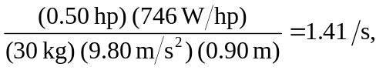
or 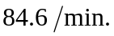 b) Similarly,
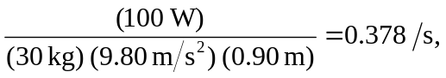
or 